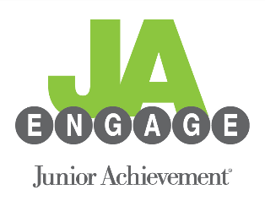
JA Engage Board Member Expectations 2021-2022

- Attend monthly meetings: Meetings are held on the second Tuesday of each month from 5:30 – 6:30 p.m. at the JA Office. Members should do their best to attend meetings regularly and in person. If they are unable to attend meetings in-person, they may occasionally join virtually.
- Volunteer for JA programs: JA Engage Board members should volunteer at least twice per year for JA programs. JA staff will occasionally arrange group volunteering opportunities for the JA Engage Board and broader membership.
- Contribute financially: All JA Engage Board members must contribute a minimum of $120 per year. Contributions can be made monthly (a minimum of $10 per month) or as an annual gift.
- Commitment: When joining the JA Engage Board, individuals are committing to their position on the Board for at least one full year. There are no term limits.
- Actively help plan and promote events: JA Engage coordinates two kinds of events: quarterly networking events for young professionals and the JA Parade of Playhouses.
  - Quarterly Networking Events: At least four times per year, JA Engage coordinates events such as happy hours, panel discussions, or other special events. It is the responsibility of JA Engage board members to help coordinate these events as needed, as well as promote these events to their colleagues and friends. Board members are responsible for bringing people to these events. JA staff provides marketing materials for you.
  - Parade of Playhouses: In summer 2021, JA Engage produced its first Parade of Playhouses event at Stanley Marketplace. This serves both as a fundraiser and as an awareness builder for JA. Local design and construction firms donate their time and materials to create incredible and imaginative children’s playhouses, which are then put on display and raffled off individually. The board decided to not hold the event in 2022 and instead use the year to plan and prepare for a late spring or early summer event in 2023. JA Engage board members must be an active participant on at least one Parade of Playhouses committee (project manager, website manager, venue manager, construction company committee, volunteer and operations committee, delivery manager, sponsorship committee).

